In the **Settings.xml file** of Maven (where ever it is installed), we have to declare the below dependencies.

1. **Proxy details of the server:**

<proxy>

<id>myhttpproxy</id>

<active>true</active>

<protocol>http</protocol>

<host>ipaddress</host>

<port>portnumber</port>

<nonProxyHosts>localhost</nonProxyHosts>

</proxy>

<proxy>

<id>myhttpsproxy</id>

<active>true</active>

<protocol>https</protocol>

<host>ipaddress</host>

<port>portnumber</port>

<nonProxyHosts>localhost</nonProxyHosts>

</proxy>

1. **Details of the Artifactory where it needs to be uploaded.**

<server>

<id>central</id>

<username>admin</username>

<password>password</password>

</server>

<server>

<id>snapshots</id>

<username>admin</username>

<password>password</password>

</server>

</servers>

<profiles>

<profile>

<repositories>

<repository>

<id>central</id>

<snapshots>

<enabled>false</enabled>

</snapshots>

<name>libs-release</name>

<url>http://10.20.126.40:8889/artifactory/libs-release</url>

</repository>

<repository>

<id>snapshots</id>

<name>libs-snapshot</name>

<url>http://10.20.126.40:8889/artifactory/libs-snapshot</url>

</repository>

</repositories>

</profile>

</profiles>

1. **Details of the repository (project name, bundles name etc):**

<repositories>

<repository>

<id>central</id>

<url>http://10.20.126.40:8889/artifactory/libs-release</url>

<snapshots>

<enabled>false</enabled>

</snapshots>

</repository>

<repository>

<id>snapshots</id>

<url>http://10.20.126.40:8889/artifactory/libs-snapshot</url>

<releases>

<enabled>false</enabled>

</releases>

</repository>

</repositories>

<pluginRepositories>

<pluginRepository>

<id>central</id>

<url>http://10.20.126.40:8889/artifactory/plugins-release</url>

<snapshots>

<enabled>false</enabled>

</snapshots>

</pluginRepository>

<pluginRepository>

<id>snapshots</id>

<url>http://10.20.126.40:8889/artifactory/plugins-snapshot</url>

<releases>

<enabled>false</enabled>

</releases>

</pluginRepository>

</pluginRepositories>

</settings>

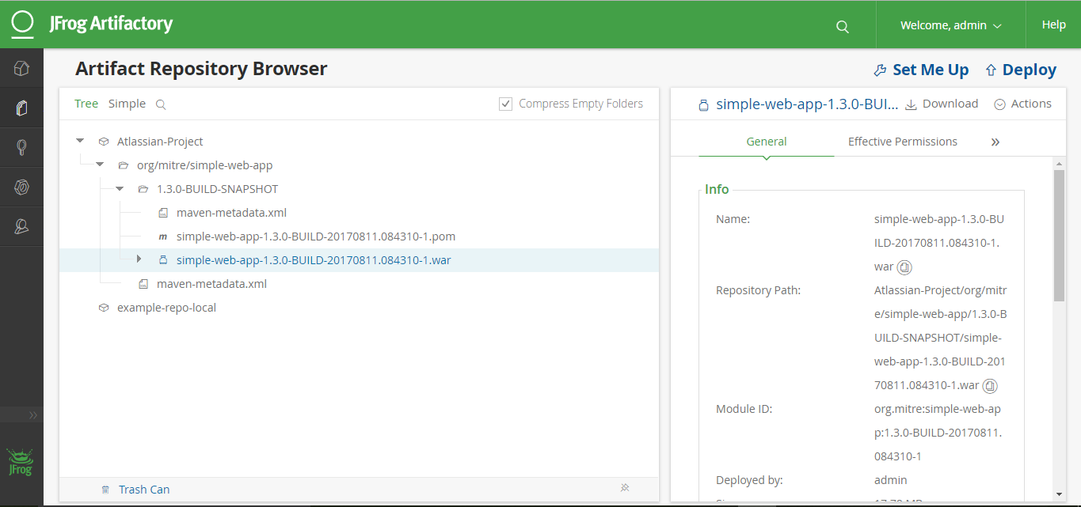

In Artifactory, we need to perform below tasks:

1. Create a new repository (Atlassian-Project),

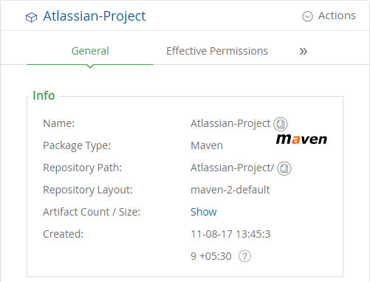

1. Click on “Set me Up” and follow below screenshot.

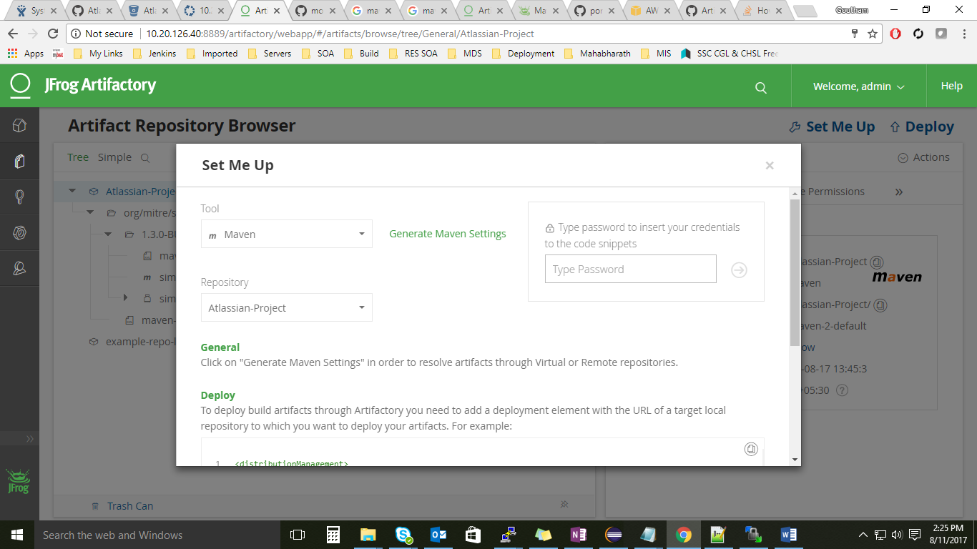

1. Add the below part in the POM.XML of the project.

<distributionManagement>

<repository>

<id>central</id>

<name>CVMP4257-releases</name>

<url>http://10.20.126.40:8889/artifactory/Atlassian-Project</url>

</repository>

<snapshotRepository>

<id>snapshots</id>

<name>CVMP4257-snapshots</name>

<url>http://10.20.126.40:8889/artifactory/Atlassian-Project</url>

</snapshotRepository>

</distributionManagement>